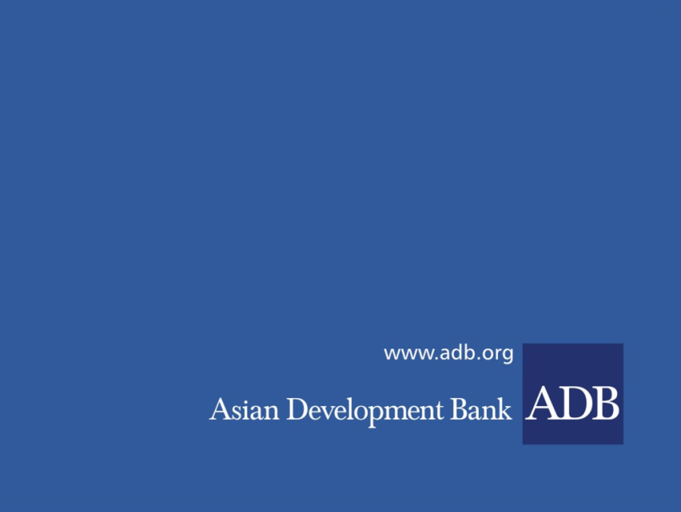

**INVITATION FOR EXRESSION OF INTEREST**

**CONSULTING SERVICES**

**CS.07 ESTABLISHMENT OF STRATEGIC PURCHASER (with duratIon of 15 MONTHS UPON CONTRACT SIGNING)**

Date: 4 November 2022

Loan No. and Title: 3843-MON:Improving Access to Health Services for Disadvantaged Groups Investment Program-Tranche 1 (49173-004)

**BACKGROUND**

The Asian Development Bank (ADB) has been Mongolia’s key health sector development partner since 1993, providing five loans totaling $84.90 million, seven grants totaling $37.00 million, and 15 technical assistance (TA) projects totaling $10.65 million. The past projects achieved significant results through comprehensive health system support and strengthening, including for PHC reform and investments, information and communications technology, medicine and pharmaceutical procurement reforms, establishment of health insurance, health infrastructure, and sector governance. Despite these achievements, Mongolia faces a continuing burden from both communicable and noncommunicable diseases, resulting in premature mortality and high levels of disability, which prevent the nation from fulfilling its economic potential.

This Project aims to support in improving health care services to marginalized populations in Ulaanbaatar ger area, Khovd and Uvs aimags, and in selected soums, development of health financing system and procurement capacity nationwide. Emergency medical care will be strengthened by providing infrastructure and medical equipment. More information about the project can be obtained from: <https://www.adb.org/projects/49173-003/main>

**OBJECTIVE OF THE ASSIGNMENT**

The consulting entity will work under direct supervision of Ministry of Health (MOH). It aims to support MOH, Health Insurance General Organization (HIGO) and health service institutions to strengthen strategic purchasing function and capacity according to its key components: (i) defining comprehensive benefit packages in line with public policy to achieve UHC, using the evidence of clinical and cost effective analysis; (ii) selective contracting of qualified providers; (iii) improving provider payment methods, assessing and correcting their disadvantages (how to buy); (iv) conducting regular costing and forecasting of health care services to reflect in benefit packages and maintain cost containments; (v) strengthening capacity of the purchaser to review and assess the quality of care; (vi) clarifying roles, functions, and authority of key stakeholders in decision-making, implementation and monitoring and evaluation of strategic purchasing; and (vii) enhancing information systems at MOH, HIGO and contracted providers for strategic purchasing and reporting.

Interested Consulting firms should provide information demonstrating that they have the required qualifications and relevant experience to perform the Services.

Following documents should be attached to the expression of interest (EOI):

* Firm’s introduction and experience history
* Copy of licenses
* References from previous Clients on successful completion of assignments and
* Proposed team composition

Interested and eligible consulting firms for this assignment should send expressions of interest together with information on relevant experiences by 3 December 2022 only via ADB’s Consultant Management System (CMS) available at <http://cms.adb.org> for the selection number 182109. Please be noted that EOI hard copy will not be considered.

**Contact information:**

The Ministry of Health of Mongolia, Project Implementation Unit.

Sukhbaatar district, Olympic Street 2,

Extension of the Government Building-8, Room No.302

Ulaanbaatar, Mongolia

Tel: +976-329369