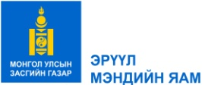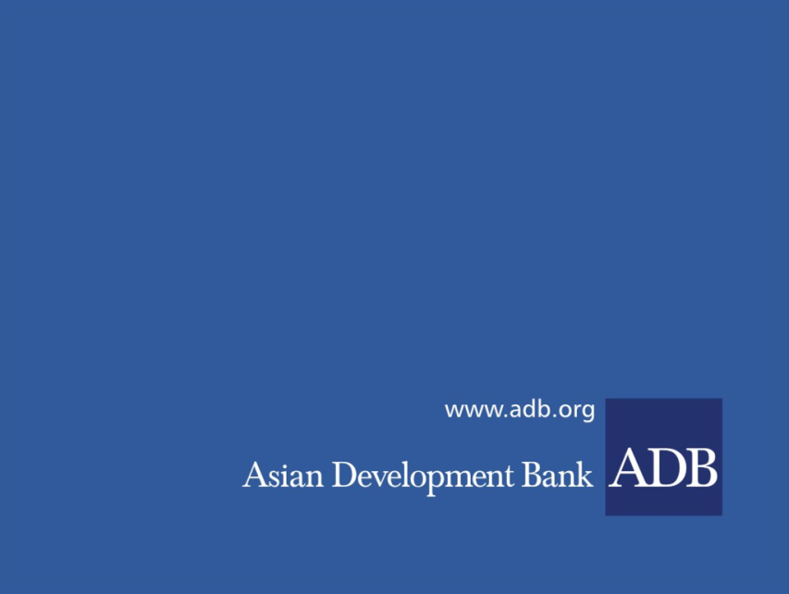

**INVITATION FOR EXRESSION OF INTEREST**

**CONSULTING SERVICES**

**CS.05 COMMUNITY CONSULTATION ENTITY**

**(WITH DURATION OF 24 MONTHS UPON CONTRACT SIGNING)**

Date: 31 October 2022

Loan No. and Title: 3843-MON:Improving Access to Health Services for Disadvantaged Groups Investment Program-Tranche 1 (49173-004)

**BACKGROUND**

The Asian Development Bank (ADB) has been Mongolia’s key health sector development partner since 1993, providing five loans totaling $84.90 million, seven grants totaling $37.00 million, and 15 technical assistance (TA) projects totaling $10.65 million. The past projects achieved significant results through comprehensive health system support and strengthening, including for PHC reform and investments, information and communications technology, medicine and pharmaceutical procurement reforms, establishment of health insurance, health infrastructure, and sector governance. Despite these achievements, Mongolia faces a continuing burden from both communicable and noncommunicable diseases, resulting in premature mortality and high levels of disability, which prevent the nation from fulfilling its economic potential.

This Project aims to support in improving health care services to marginalized populations in Ulaanbaatar ger area, Khovd and Uvs aimags, and in selected soums, development of health financing system and procurement capacity nationwide. Emergency medical care will be strengthened by providing infrastructure and medical equipment. More information about the project can be obtained from: <https://www.adb.org/projects/49173-003/main>

**OBJECTIVE OF THE ASSIGNMENT**

The consulting entity (the Consultant) will support the PIU to organize and communicate public relation activities regarding on project's reform strategies, goals, its importance, results to the stakeholders such as policy makers, healthcare professionals and to the general population.

The Ministry of Health now invites eligible consulting firms to indicate their interest in providing the Consulting service “Community consultation” to i) promote community participation at Project site hospitals through outreach activities; ii) Develop gender sensitive media content on project implementation and outputs v) organize dissemination of media to the general public and concerned stakeholders; Key messages will focus on hospital sector reforms (Khan-Uul and Chingeltei district hospitals, Uvs and Khovd aimag’s general hospitals), a new development concept and technologies for family health centers in Ulaanbaatar and soum health centers in a selected aimags. and single purchaser principle in health financing.

Interested Consulting firms should provide information demonstrating that they have the required qualifications and relevant experience to perform the Services.

Following documents should be attached to the expression of interest (EOI):

* Firm’s introduction and experience history
* Copy of licenses
* References from previous Clients on successful completion of assignments and
* Proposed team composition

Interested and eligible consulting firms for this assignment should send expressions of interest together with information on relevant experiences by 29 November 2022 only via ADB’s Consultant Management System (CMS) available at <http://cms.adb.org> for the selection number 182956. Please be noted that EOI hard copy will not be considered.

**Contact information:**

The Ministry of Health of Mongolia, Project Implementation Unit.

Sukhbaatar district, Olympic Street 2,

Extension of the Government Building-8, Room No.302

Ulaanbaatar, Mongolia

Tel: +976-329369